**HOMEWORK0**

* Screenshot of tableau account:

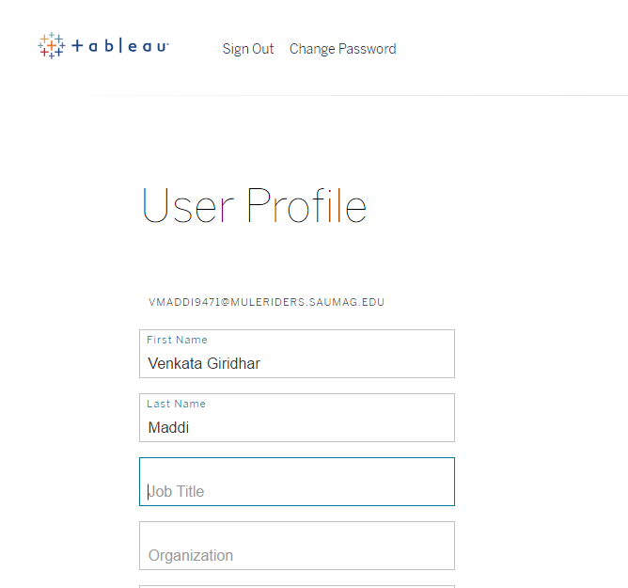

* Screenshot of GitHub account:

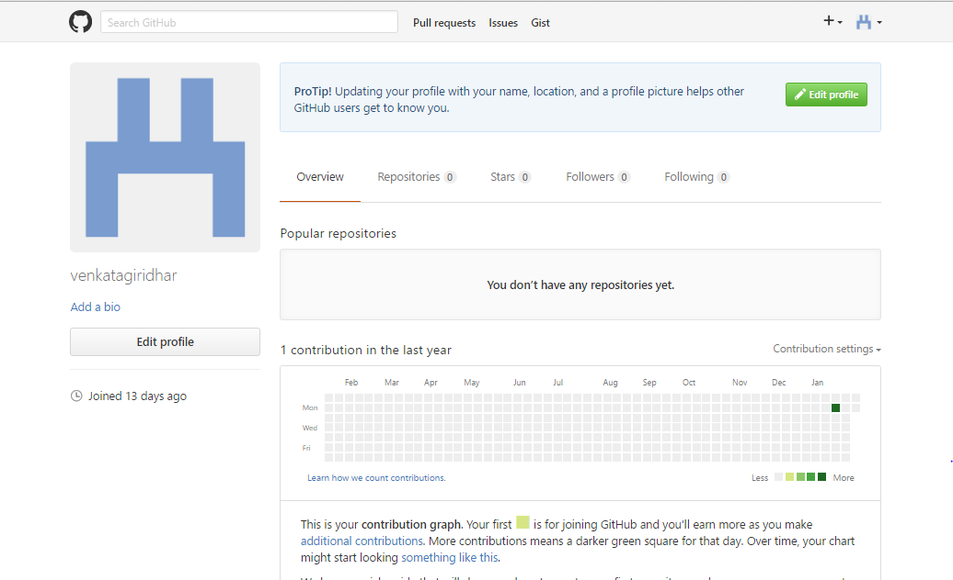

* Explored Tableau report on a smart-phone breakdown.

1. This chart represents the look at how smart phone manufacturers must make trade-offs various components of modern day smartphones.
2. The chart shows cost data broken down by model for the Apple iPhone and Samsung Galaxy S series of phones.
3. They are focusing on components like camera, connectivity, core electronics, display/touch panel/glass, memory, power, sensor etc.
4. They are comparing smartphone model with the percent of components as well as cost. We can hover the mouse on each segment to get details of phone and the component cost at the time of release.
5. We can switch between a chart displaying proportional and absolute costs using the radio buttons on the right.

Tableau report link: <https://public.tableau.com/en-us/s/gallery/smartphone-breakdown>

Tableau chart for smartphone breakdown shows below:

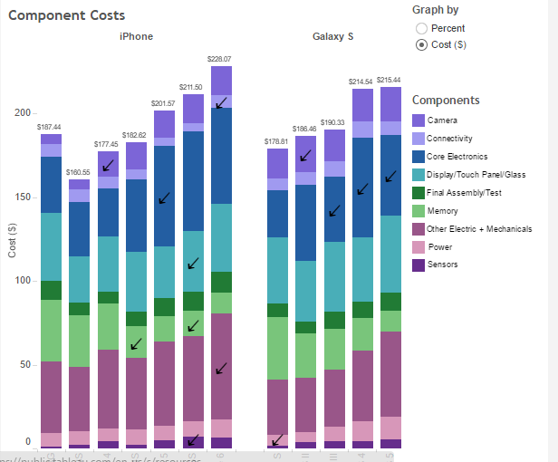

* Explored GitHub repository on ASP.NET

1. Git is an open-source version control system used by the people for making constant changes without losing the previous data. Stores the modifications in a central repository by versioning every changes.
2. A repository is a location where all the files for a particular project are stored, usually abbreviated to “repo”. Each project will have its own repo, and can be accessed by a unique URL.
3. If you find a project on GitHub that you’d like to contribute to, you can fork the repo, make the changes you’d like, and release the revised project as a new repo.
4. You can do so by creating a pull request, so the authors of the original repository can see your work, and then choose whether or not to accept it into the official project.
5. Also we can create, upload, find and download the files present in the repository.
6. In this repository there are lot of files contains the code examples for each concept like error-handling, fundamentals, dependency-injection etc.

Repository Link: <https://github.com/aspnet/Docs>

Screenshot of repository:

